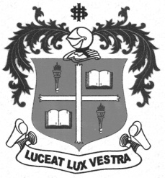
LOYOLA COLLEGE (AUTONOMOUS), CHENNAI – 600 034
B.A. DEGREE EXAMINATION – HISTORY
FIFTH SEMESTER – APRIL 2012

HT 5402 - HISTORY OF CHENNAI

Date : 30-04-2012 Dept. No. Max. : 100 Marks
Time : 1:00 - 4:00
PART – A

Answer any TEN of the following in about TEN lines each: (10x2=20 marks)

- St. Thomas
- Fort St. George
- Bank of Madras
- Railways in Madras
- Thomas Munro
- General Hospital
- Madras Mahajana Sabha
- Blavatsky and Olcott
- Binny and Company
- Muthulakshmi Reddy
- The Hindu
- Manirathnam
PART – B

Answer any FOUR of the following in about ONE page each: (4x10=40 marks)

- Describe the antiquity of Chennai with examples.
- Estimate the contribution of Elihu Yale.
- Mention the various phases of British Administration in Chennai.
- Madras is associated with the origins of the Freedom Movement. Explain.
- Trace briefly the History of Loyola College, Chennai.
- Assess the contribution of Chennai to Carnatic Music.
PART – C

Answer any TWO of the following in FOUR pages each:
(2x20=40 marks)
- Estimate the contribution of Tamil and English Journalism in Chennai.
- Evaluate the contribution of various hospitals in Chennai.
- Give details of the development of industries in Chennai.
- Assess Chennai’s contribution to the Dravidian Movement.

**********

